# Spotfire Analyst Installation and Login

1. Login to TIBCO edelivery website using below URL:

<https://edelivery.tibco.com/storefront/index.ep>

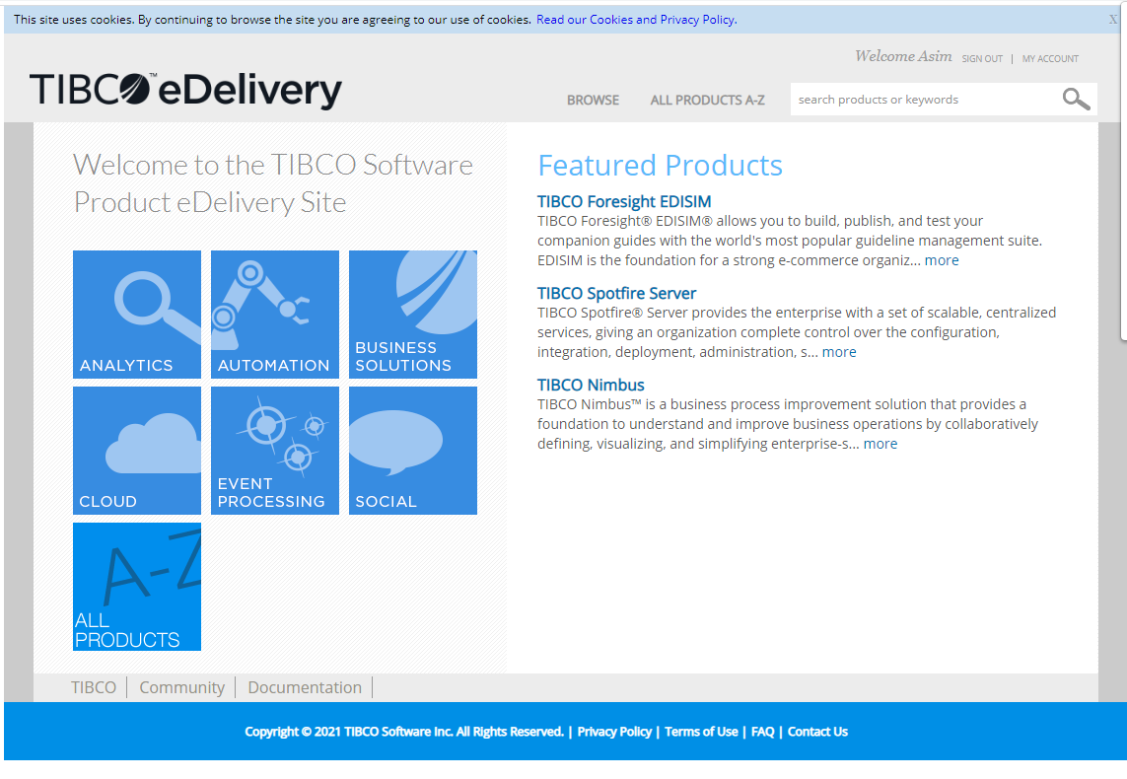

1. Search for “spotfire analyst”. Click on “TIBCO Spotfire Analyst” :

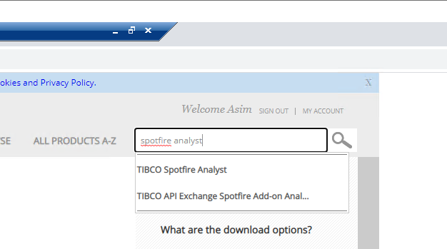

1. Click Download

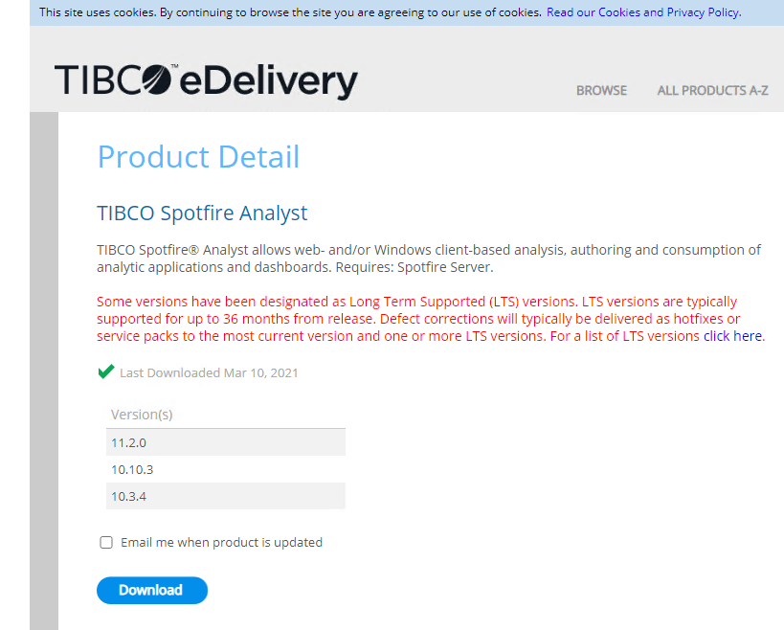

1. Select version and OS as mentioned:

**Version: 11.5.0 (Reata Spotfire server recently upgraded from 11.2 to 11.5)**

**OS: Windows**

Check the user agreement and click “Download”

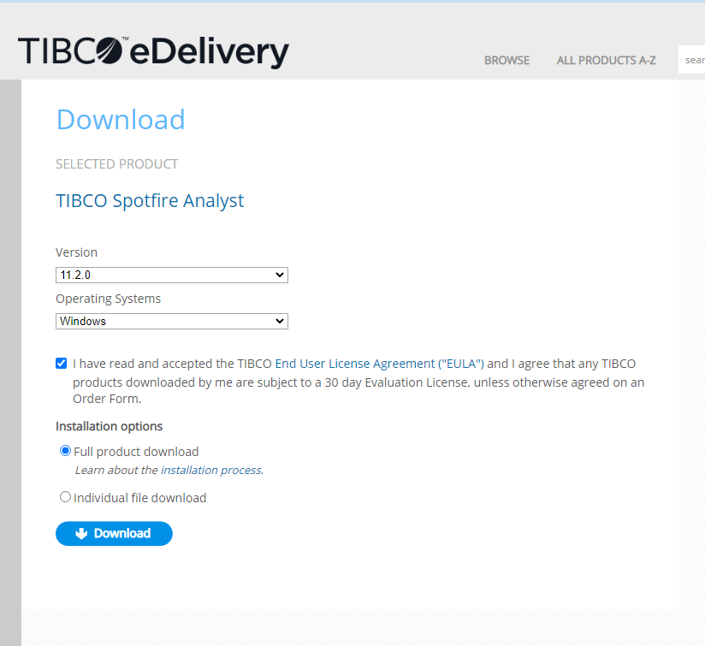

1. New dialog box will open. Click “Get Download”

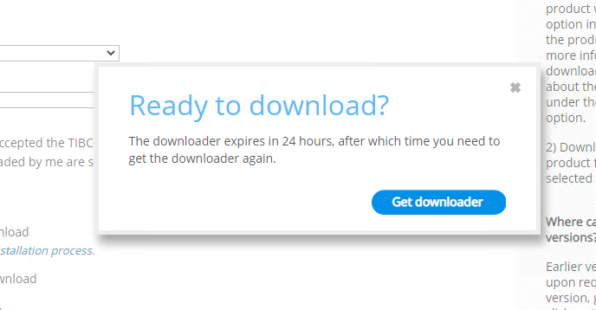

1. Double- Click on the downloaded file, a new window will open. Select the folder where software setup file will be downloaded ( or use the default ) and click Next

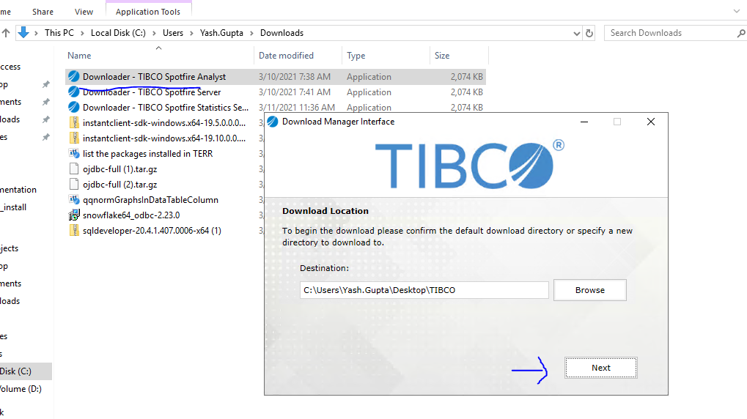

1. Click “Open Folder” once the download completes:

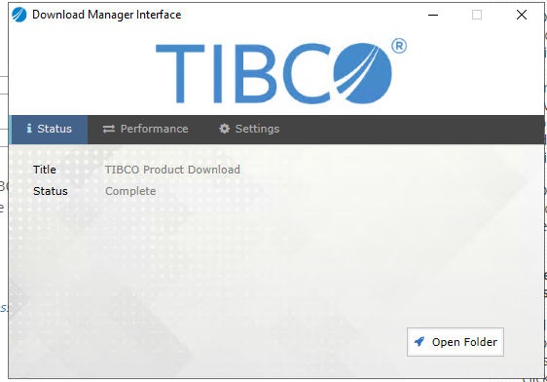

1. Navigate to the downloaded folder and extract the “**TIB_sfire-analyst_11.5.0_shared_computer_win**” file as shown in below screenshot:

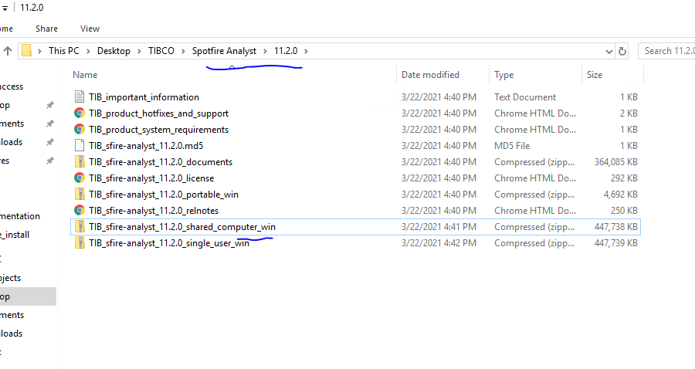

1. Navigate to the newly extracted folder and run the setup

~\TIBCO\Spotfire Analyst\11.2.0\TIB_sfire-analyst_11.5.0_shared_computer_win\Products\TIBCO Spotfire Installer

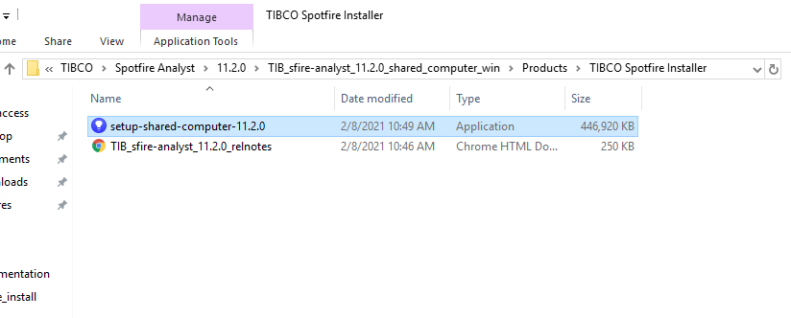

1. Click “Next”

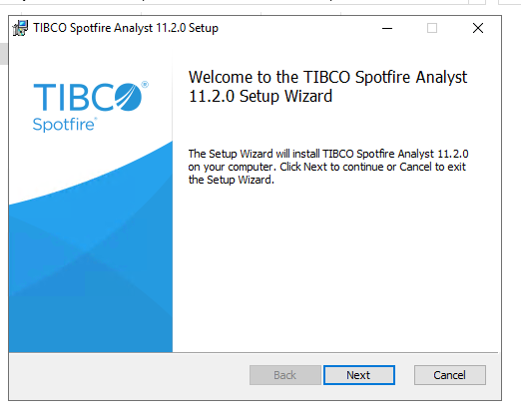

1. Accept the user agreement and click Next

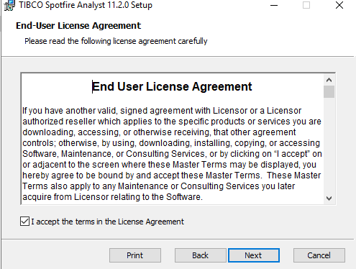

1. Click Next

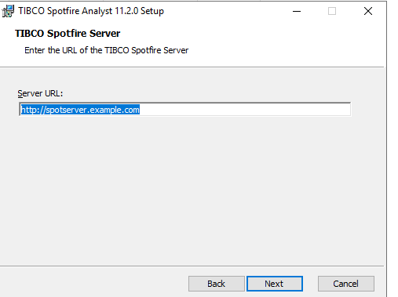

1. Click “Install”

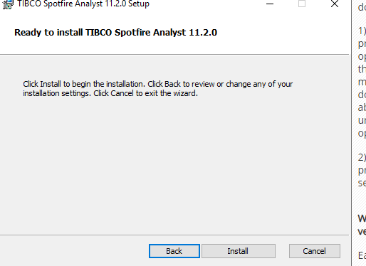

1. Click “Finish”

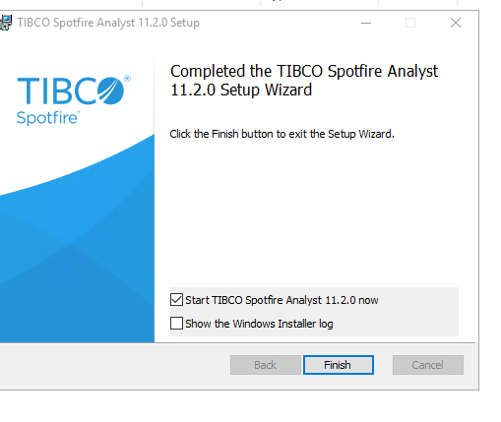

1. Click on “Manage Servers” on the login screen
2. Click on Add and enter the below URL. Display name can be personalized as per user:

DEV Server URL :- XYZ

PROD Server URL:- XYZ

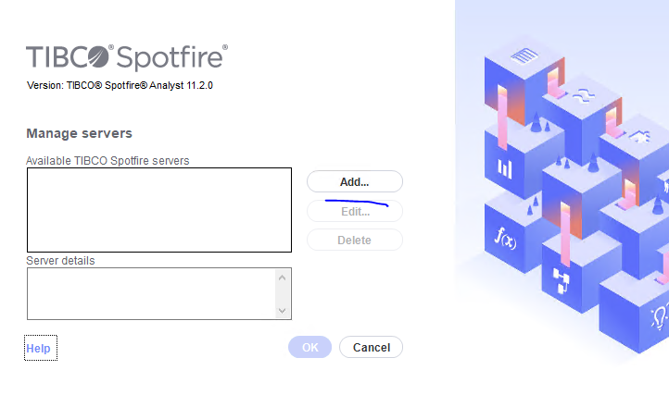

1. Login with the your Windows AD User credentials

Ex: Username: [abc.xyz@](mailto:abc.xyz@reatapharma.com)xyz.com

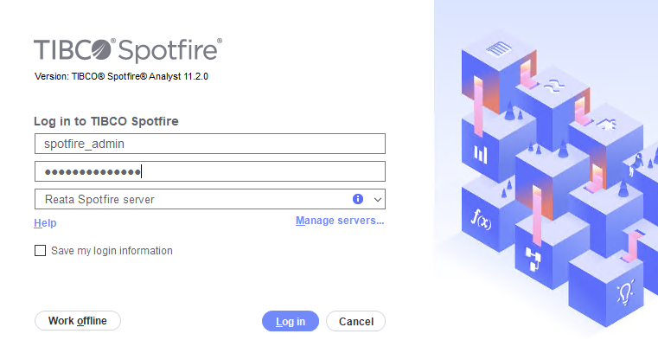

1. Click “Install Now” in case an upgrade window pops up to sync Spotfire client version with that of Spotfire Server.